**Hibernate Collection Mapping**

* Create one database in mysql

And Execute below query

****************hibernate collection mapping*******************************

DROP TABLE IF EXISTS `colors`;

/*!40101 SET @saved_cs_client = @@character_set_client */;

/*!40101 SET character_set_client = utf8 */;

CREATE TABLE `colors` (

`ID` bigint(20) NOT NULL AUTO_INCREMENT,

`color_name` varchar(40) DEFAULT NULL,

`idx` int(11) DEFAULT NULL,

`product_id` bigint(20) DEFAULT NULL,

PRIMARY KEY (`ID`)

) ENGINE=InnoDB AUTO_INCREMENT=6 DEFAULT CHARSET=latin1;

/*!40101 SET character_set_client = @saved_cs_client */;

--

-- Dumping data for table `colors`

--

LOCK TABLES `colors` WRITE;

/*!40000 ALTER TABLE `colors` DISABLE KEYS */;

INSERT INTO `colors` VALUES (1,'Red',0,1),(2,'Silver',1,1),(3,'Gray',0,2),(4,'White',1,2),(5,'Maroon',0,3);

/*!40000 ALTER TABLE `colors` ENABLE KEYS */;

UNLOCK TABLES;

--

-- Table structure for table `eproduct`

--

DROP TABLE IF EXISTS `eproduct`;

/*!40101 SET @saved_cs_client = @@character_set_client */;

/*!40101 SET character_set_client = utf8 */;

CREATE TABLE `eproduct` (

`ID` bigint(20) NOT NULL AUTO_INCREMENT,

`name` varchar(100) DEFAULT NULL,

`price` decimal(10,2) DEFAULT NULL,

`date_added` timestamp NOT NULL DEFAULT CURRENT_TIMESTAMP,

PRIMARY KEY (`ID`)

) ENGINE=InnoDB AUTO_INCREMENT=4 DEFAULT CHARSET=latin1;

/*!40101 SET character_set_client = @saved_cs_client */;

--

-- Dumping data for table `eproduct`

--

LOCK TABLES `eproduct` WRITE;

/*!40000 ALTER TABLE `eproduct` DISABLE KEYS */;

INSERT INTO `eproduct` VALUES (1,'HP Laptop ABC',21900.00,'2019-06-04 07:18:57'),(2,'Acer Laptop ABC',23300.00,'2019-06-04 07:19:07'),(3,'Lenovo Laptop ABC',33322.00,'2019-06-04 07:19:19');

/*!40000 ALTER TABLE `eproduct` ENABLE KEYS */;

UNLOCK TABLES;

--

-- Table structure for table `finance`

--

DROP TABLE IF EXISTS `finance`;

/*!40101 SET @saved_cs_client = @@character_set_client */;

/*!40101 SET character_set_client = utf8 */;

CREATE TABLE `finance` (

`ID` bigint(20) NOT NULL AUTO_INCREMENT,

`ftype` varchar(10) DEFAULT NULL,

`name` varchar(30) DEFAULT NULL,

`product_id` bigint(20) DEFAULT NULL,

PRIMARY KEY (`ID`)

) ENGINE=InnoDB AUTO_INCREMENT=6 DEFAULT CHARSET=latin1;

/*!40101 SET character_set_client = @saved_cs_client */;

--

-- Dumping data for table `finance`

--

LOCK TABLES `finance` WRITE;

/*!40000 ALTER TABLE `finance` DISABLE KEYS */;

INSERT INTO `finance` VALUES (1,'CREDITCARD','EMI on Citibank Card',1),(3,'BANK','40% finance from SBI',2),(4,'BANK','60% finance from ICICI',3),(5,'BANK','20% finance from ICICI',1);

/*!40000 ALTER TABLE `finance` ENABLE KEYS */;

UNLOCK TABLES;

--

-- Table structure for table `os`

--

DROP TABLE IF EXISTS `os`;

/*!40101 SET @saved_cs_client = @@character_set_client */;

/*!40101 SET character_set_client = utf8 */;

CREATE TABLE `os` (

`ID` bigint(20) NOT NULL AUTO_INCREMENT,

`name` varchar(30) DEFAULT NULL,

`product_id` bigint(20) DEFAULT NULL,

PRIMARY KEY (`ID`)

) ENGINE=InnoDB AUTO_INCREMENT=6 DEFAULT CHARSET=latin1;

/*!40101 SET character_set_client = @saved_cs_client */;

--

-- Dumping data for table `os`

--

LOCK TABLES `os` WRITE;

/*!40000 ALTER TABLE `os` DISABLE KEYS */;

INSERT INTO `os` VALUES (1,'Windows 10',1),(2,'Windows 10',2),(3,'FreeDOS',2),(4,'RedHat Linux',2),(5,'Windows 10',3);

/*!40000 ALTER TABLE `os` ENABLE KEYS */;

UNLOCK TABLES;

--

-- Table structure for table `screensizes`

--

DROP TABLE IF EXISTS `screensizes`;

/*!40101 SET @saved_cs_client = @@character_set_client */;

/*!40101 SET character_set_client = utf8 */;

CREATE TABLE `screensizes` (

`ID` bigint(20) NOT NULL AUTO_INCREMENT,

`size` varchar(10) DEFAULT NULL,

`product_id` bigint(20) DEFAULT NULL,

PRIMARY KEY (`ID`)

) ENGINE=InnoDB AUTO_INCREMENT=5 DEFAULT CHARSET=latin1;

/*!40101 SET character_set_client = @saved_cs_client */;

--

-- Dumping data for table `screensizes`

--

LOCK TABLES `screensizes` WRITE;

/*!40000 ALTER TABLE `screensizes` DISABLE KEYS */;

INSERT INTO `screensizes` VALUES (1,'12 in',1),(2,'14.5 in',2),(3,'14.9 in',2),(4,'15.5 in',3);

/*!40000 ALTER TABLE `screensizes` ENABLE KEYS */;

UNLOCK TABLES;

This all Tables are connected with eproduct via One to many Relationship

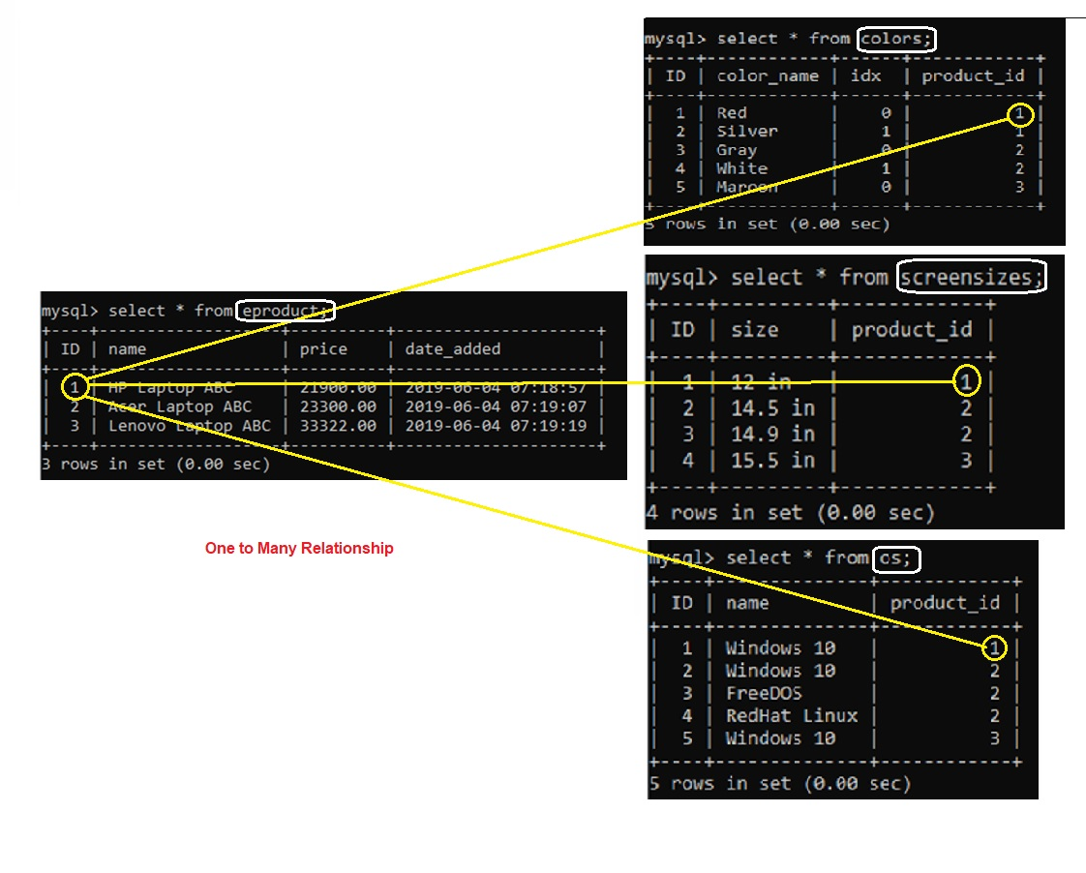

Then do the mapping for Colors, Eproduct,OS as shown in Java Code